

Page One of Six

Desi is the leading manufacture of telephone labeling programs. By following a few steps will allow you to edit your phones printed labels, at anytime.

Step 1: To acquire Desie Lite, the free software version, cut and paste the below link into your internet browser’s address field.

http://www.desi.coresense.com/info-exec/display/downloads

You should see:
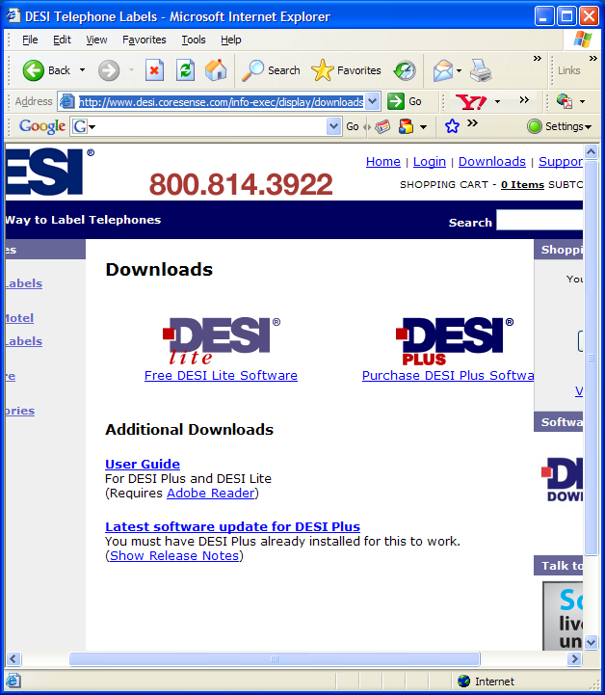

Page Two of Six

Step 2: Click on “Free DESI Lite Software.

You should see:
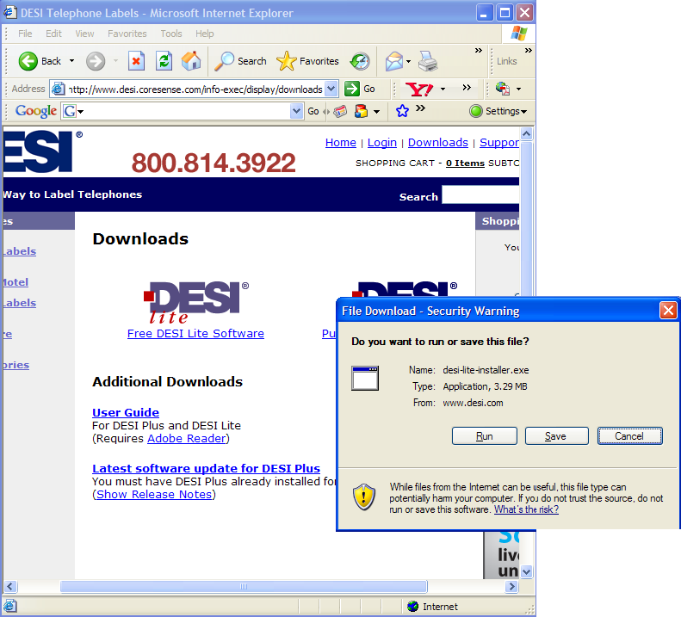

Step 3: Select “Run”

You should see:
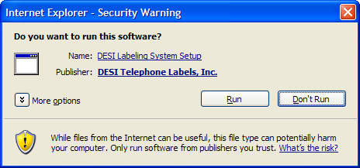

Page Three of Six

Step 4: Select “Next”

You should see:
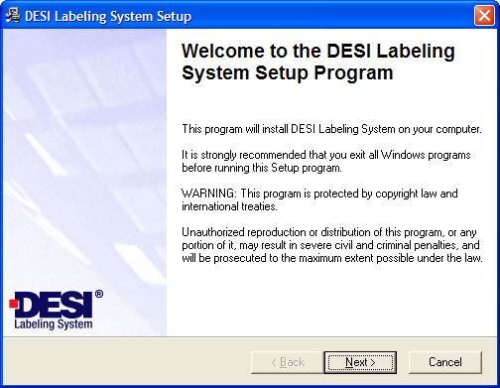

Step 5: Select “Next”

You should see:
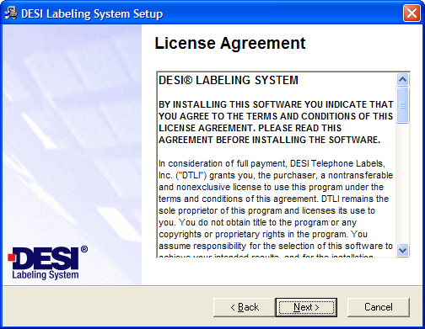

Page Four of Six

Step 6: Select “Next”

You should see:
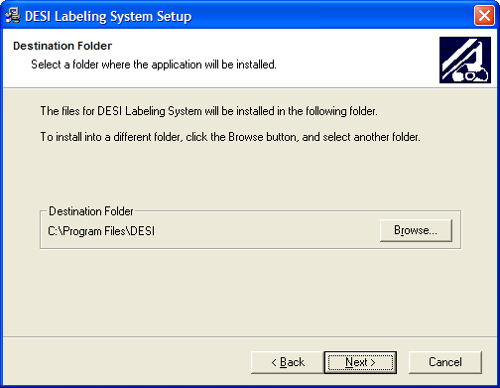

Step 6: Select “Finished”

You should see:
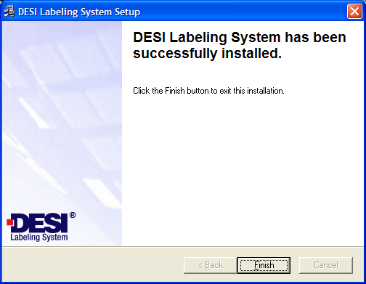

Page Five of Six

Step 4: To obtain the detailed user guide please cut and paste the below link into your internet browser’s address field.

http://www.desi.com/info-exec/display/downloads

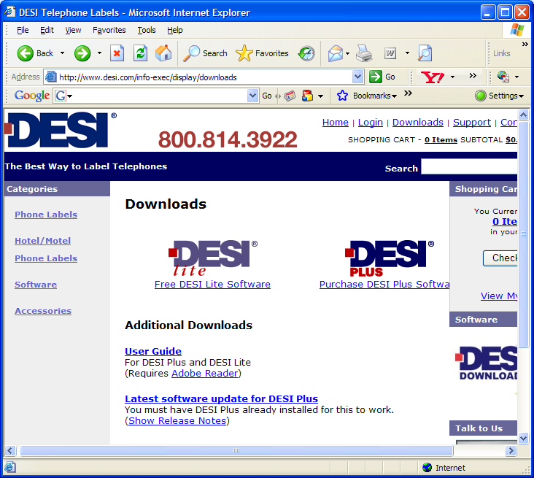

Page Six of Six

Step 5: To obtain the proper labels for your telephones please cut and paste the below link into your internet browser’s address field.

http://www.desi.com/category-exec/category_id/3/nm/Phone_Labels

